

Location Analysis of Possible Planting Space for Urban Forests in Austin, TX

Tree Planting Location Services (T.P.L.S)

Project Manager: Eric Fotey
Researchers/GIS Analysts:
Samantha Bechthold
William Kesler
Emily Lundy

3/31/21
- Introduction

1.1 Summary
The City of Austin Urban Forestry Services have recruited the Tree Planting Location Services (TPLS) to find the total area within the Austin city limits and surrounding watershed area that are available for planting trees. TPLS is using ArcGIS Pro to find the current greenspaces and to remove unplantable areas in order to produce a map that will show all of the possible planting spaces (PPS) within our scope. TPLS will provide the client with a percent that represents the full tree canopy capacity within Austin. We will also be updating the community tree priority areas layer to reflect the new data for % PPS, existing canopy, and potential canopy and find which tracts have the highest and lowest percentages for each of the aforementioned data sets. The resulting map will help policymakers in making big decisions about Austin’s urban forests, and work towards keeping Austin green.

1.2 Purpose
The purpose of this study is to provide our client with the total potential area within the city of Austin that can be used to plant trees. The focus of planting trees within Austin is to help reduce the total output of carbon emissions in the area as well as reduce the severity of the urban heat island. We will analyze data regarding impervious cover, tree canopy density and watershed limitations in order to provide the total area of planting space. The data used in this study has been provided by the Urban Forestry Services of the City of Austin. The analysis of this data will result in a visual map that portrays the potential planting space within the urban land use throughout the Austin city limits. To achieve this, we will apply GIS mechanics to exclude attributes that are not potential planting space.

1.3 Scope
The scope of the project encompasses the city of Austin as well as the surrounding areas that are within Austin’s watershed boundaries. The Austin-bergstrom international airport has been excluded due to regulations in that area that prevent trees from being planted there. Figure 1 below shows the full extent of the project and includes information regarding priority levels for planting trees throughout the city.
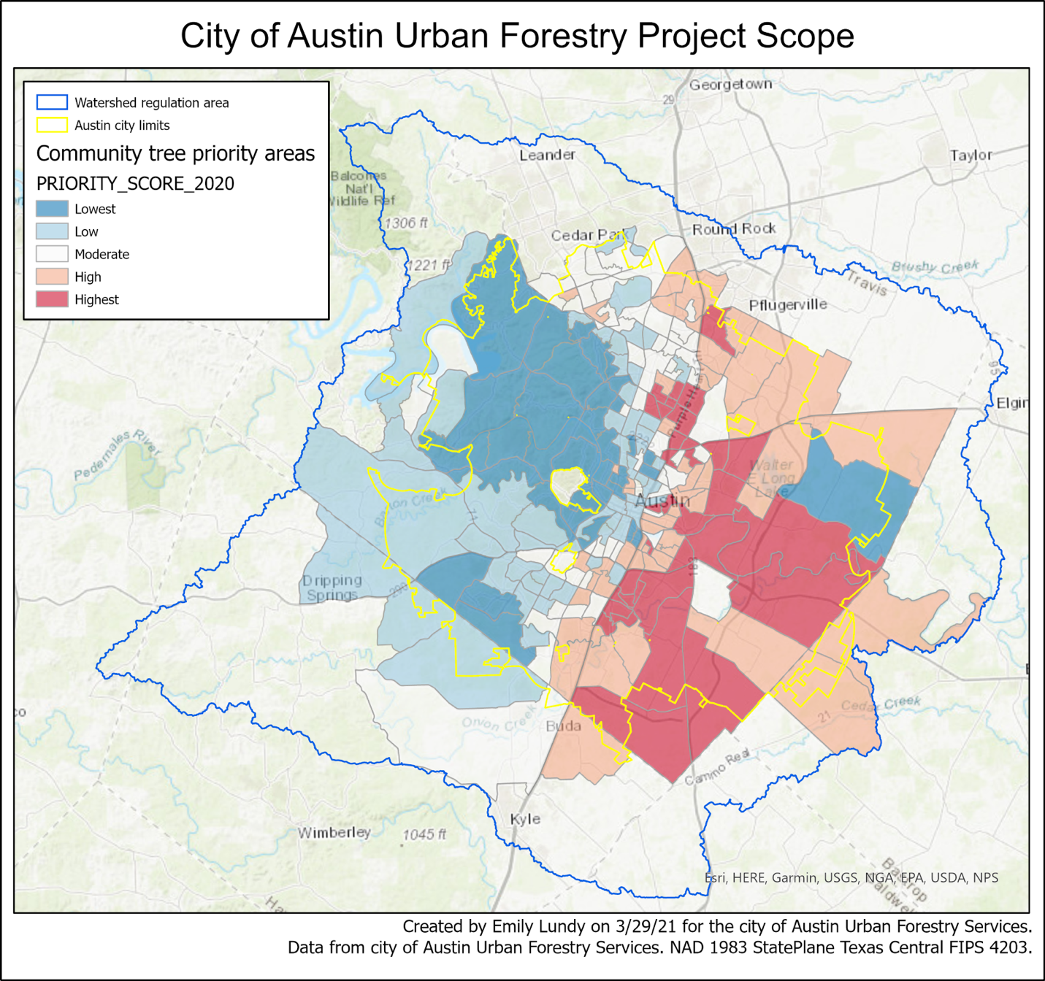
Figure 1. Project Scope

- Tasks

  - Work Completed
We started out by converting everything to the same format since we needed to merge and erase. We decided on using a vector because only the tree canopy layer needed to be converted. Then we erased the surface water and the airport from the data set, and we also merged the canopy and impervious cover since this is all done as a vector in 1m resolution over the whole Austin water shed, all these geoprocesses took a very long time to complete.
2.2 Present Work
We have been working on figuring out a way to erase the merged impervious cover data and the canopy data. We cannot just use the erase tool when they are in vector because the data set is too large it would take much too long to complete. Therefore, we are going to convert it into a raster and run the less than tool to differentiate the background layer with the non plantable space. Then, we plan to analyze the area by looking at each census tract one by one and figuring out what differentiates them. Then we are going to intersect the plantable space with the census tracts to analyze each region in Austin individually.

2.3 Work Scheduled
In the next couple of weeks, we intend to find the % PPS, % existing canopy, and % potential canopy using the intersect tool. Once we have found those percentages, we will be able to determine which community tree planting areas have the highest and lowest % PPS, % existing canopy, and % potential canopy which will allow us to see which parts of Austin should be highest priority for planting trees. Table 1 shows our revised timetable. Work is going according to plan so far with few revisions needed. The revisions that were made were minor adjustments to the dates for the client visits due to the winter storm and resulting power outages that we experienced mid-February. The green cells show work that has already been completed while the blue cells show work that is still in progress.

Table 1. Revised Timetable
Date | Activity | Notes
1/27 | 1st client visit | Received request for proposal
1/27 – 3/1 | Collect data | All data layers received from client on 2/15
2/15-3/1 | Create Proposal | Unable to work on proposal for the first week due to winter storm, resulted in changed timetable as of 3-1
3/1-3/2 | Edit Proposal | Make minor changes based on recommendation of Professor Yuan.
3/3 | 2nd client visit | Present proposal, make modifications at client request
3/1 – 3/15 | Pre-process data | Prepare data for analysis
3/17 – 4/7 | Data analysis | Perform GIS analysis of the data
3/31 | 3rd client visit | Give client progress report and get feedback
4/5 – 4/9 | Edit project | Make adjustments based on client’s feedback
4/12 – 4/26 | Data interpretation | Interpret the results of GIS analysis
5/3 | Final Presentation | Present final product to client

2.4 Problems
The data set is very large, leading to extremely long processing times when trying to merge and convert to raster/polygon. In some cases, the loading bar would stop at 22% and not move up one percent for hours so we would have to cancel and try something else. We had a set back where we used the repair tool at one step and the data set got corrupted, so we had to restart.

3. Conclusion
Overall, the project has been off to a fairly slow start because of the delays in merging and other processes due to the very large size of the files but now that we have successfully completed the merging process, the rest of the project should move along much faster. We anticipate the next steps to be much less time consuming and at this point in time we are on schedule to finish our project by the end of April.

